Azure Traffic Manager

## **What is Traffic Manager?**

Traffic Manager is a service provided by Azure to balance the end user traffic load of services like web app, cloud service or VMs across multiple instances or endpoints, hosted in azure. It enables to define the routing policies for services hosted in Azure and traffic redirected according to the policies. It also improves the availability and performance of applications. Traffic manager is a DNS-based service; it is not a proxy or a gateway and does not see the traffic passing between the client and the service.

## **How Traffic Manager works?**

Traffic Manager uses the Domain Name System (DNS) to direct client requests to the most appropriate endpoint based on a traffic-routing method and the health of the endpoints. Traffic Manager provides four traffic-routing methods to determine how users should be redirected to different instances or endpoints to suit different application needs and automatic failover. Traffic Manager is robust enough to handle failure across entire Azure regions.

Following are the routing methods supported by Traffic Manager

Priority**:** This routing method is used to set primary service endpoint for all traffic, and provide backups in case the primary endpoint is unavailable.

Weighted**:**This method is used to distribute traffic across set of endpoints according to weights, which you define.

Performance**:**This method is used to redirect end users to use the “closest” endpoint across globe in terms of the lowest network latency.

Geographic**:**Users are directed to specific endpoints based on which geographic location their DNS query originates from.

## **When to use Traffic Manager?**

Consider a company which has global presence and want to create a web app to connect with all the global partners. The application need to be hosted in multiple regions of Azure and provide better performance and high availability to end users. In this scenario we need to use Traffic Manager to distribute client traffic to the closest available endpoint or instance.

Let’s take above example and see how we can use traffic manager.

* Deploy three instances of service in three different regions. The DNS names of these deployments are ‘mywebapp-us.azurewebsites.net’, ”mywebapp-eu.azurewebsites.net’, and ”mywebapp-asia.azurewebsites.net’.
* Create a Traffic Manager profile, named ‘mywebapp.trafficmanager.net’, and configure it to use the ‘Performance’ traffic-routing method across the three endpoints.
* Configure their main domain name, ‘partners.mywebapp.com’, to point to mywebapp.trafficmanager.net’, using a DNS CNAME record.

Following image illustrates how traffic manager works when end user sends request on a main domain which is mapped to traffic manager.

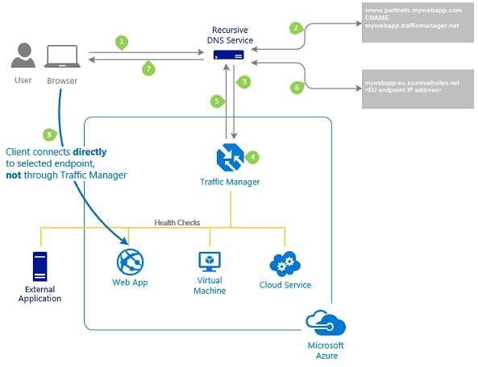Traffic Manager Routing

If user requests a page [www.partners.mywebapp.com/login.aspx](http://www.partners.mywebapp.com/login.aspx), following sequence of requests is followed to server the page.

* The client sends a request to its configured recursive DNS service to resolve the DNS name; it finds the name servers for the ‘mywebapp.com’ domain. It then contacts those name servers to request the ‘partners.mywebapp.com’ DNS record, it returns the CNAME record that points to mywebapp.trafficmanager.net.
* Recursive DNS service finds the name servers for the ‘trafficmanager.net’ domain, which are provided by the Azure Traffic Manager service. It then sends a request for the ‘mywebapp.trafficmanager.net’ DNS record to those DNS servers.
* The Traffic Manager Name servers receive the request. It choose an endpoint based on the traffic-routing method.
* The chosen endpoint is returned as another DNS CNAME record. In this case, let us suppose mywebapp-eu.azurewebsites.net is returned.
* Recursive DNS service finds the name servers for the azurewebsites.net domain. It contacts those name servers to request the ‘mywebapp-eu.azurewebsites.net’ DNS record. A DNS ‘A’ record containing the IP address of the eu-based service endpoint is returned.
* The recursive DNS service consolidates the results and returns a single DNS response to the client.
* The client receives the DNS results and connects to the given IP address. The client connects to the application service endpoint directly, not through Traffic Manager. Since it is an HTTPS endpoint, the client performs the necessary SSL/TLS handshake, and then makes an HTTP GET request for the ‘/login.aspx’ page.

## **Why use Traffic Manager?**

High availabilityTraffic Manager delivers high availability for applications by monitoring endpoints and providing automatic fail-over when an endpoint goes down.

Responsiveness ApplicationsAzure allows to run cloud services or websites in data-centers located around the world. Traffic Manager improves application responsiveness by directing traffic to the endpoint with the lowest network latency for the client.

Maintenance without downtimeTraffic Manager directs traffic to alternative endpoints while the maintenance is in progress.

Hybrid cloud deploymentsTraffic Manager support external, non-Azure endpoints enabling it to be used with hybrid cloud and on-premises deployments.

## **Step by Step Configuration of Azure Traffic Manager**

### **Step 1: Deploy three instances of service in three different regions**

Create three web apps across three different regions as follows

mywebapp-us.azurewebsites.net for US region  
mywebapp-eu.azurewebsites.net for Europe region  
mywebapp-asia.azurewebsites.net for Asia region

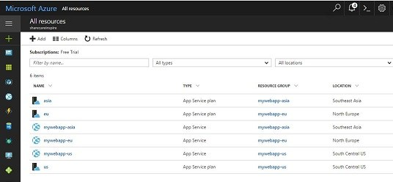Region wise Web Apps

Asia web app page looks like follows which is standard page shown by default when web app is created , similar are the default pages of US and EU web apps.

Default Page of Web App

### **Step 2: Create a Traffic Manager profile**

Create traffic manager profile ‘mywebappsci.trafficmanager.net’, and configure it to use the ‘Performance’ traffic-routing method across the three endpoints.

On the Hub menu, click New > Networking > See all, click Traffic Manager Profile to open the Create Traffic Manager profile blade, and then click Create.

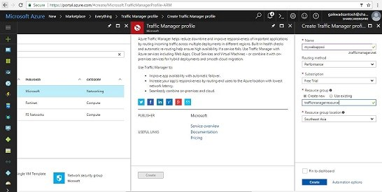Create Traffic Manager Profile

### **Step 3: Add App service endpoint to a Traffic Manager profile**

* In the portal’s search bar, search for the Traffic Manager profile name that you want to modify, and then click the Traffic Manager profile in the results that the displayed.
* In the Traffic Manager Profile blade, in the Settings section, click Endpoints.
* In the Endpoints blade that is displayed, click Add.

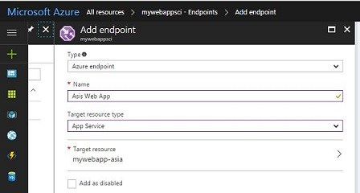Add Traffic Manager endpoints

Similarly create endpoints for all the web apps deployed across Asia, US and Europe.

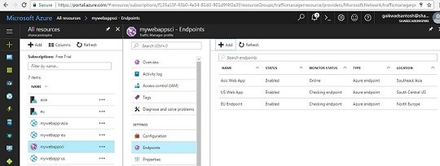List of endpoints to traffic manager

When you create a Traffic Manager profile, Azure automatically assigns a DNS name for that profile. You can find the Traffic Manager Domain name in the **General** section on the Configuration page of the Traffic Manager profile.

Now traffic manager is configured properly and if you visit the URL of the traffic manager you will able to see the web part of nearest web app provided it is healthy as we have configured performance routing method here.

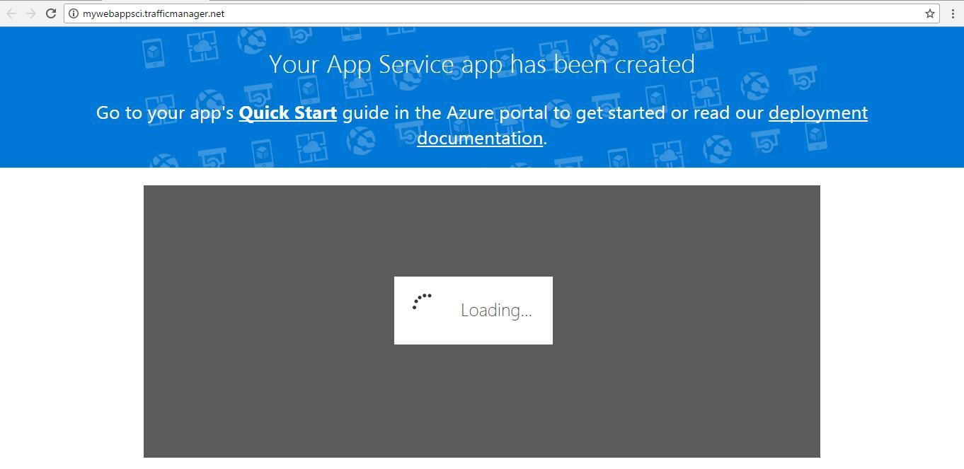Traffic Manager Web Page

### **Step 4: Point own domain to an Azure Traffic Manager domain**

Next step is to map your company domain name to traffic manager domain. For example, to point name www.mywebappsci.com to the Traffic Manager DNS name mywebappsci.trafficmanager.net. To point your company domain name to a Traffic Manager domain name, need to modify the DNS resource record on your Internet DNS server to use the CNAME record type, which maps your company domain name to the domain name of your Traffic Manager profile. You can see the Traffic Manager domain name in the **General** section on the Configuration page of the Traffic Manager profile.

For this tutorial i have not bought domain hence will not able to show actual configuration.

### **Step 5: Test if traffic manager is working fine.**

To test the configuration, if traffic manager is working fine or not, we need to navigate to either traffic manager URL or the custom domain URL if you have configured the same. In my case I have not bought custom domain, hence testing with traffic manager URL.

* Make changes to the default page of web apps of each region, which we have created. I have updated default pages of web apps with map of that region on the page. if you want to know how to make changes to default page, please refer article [here](http://www.sharecareinspire.com/how-to-make-changes-to-pages-and-files-on-web-apps-form-arm-portal/)

e.g. Web app of Europe will look as follows.

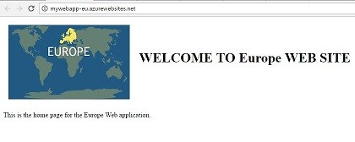Europe Web App

* after making changes for all web app, lets test with traffic manager URL. I am based out of India (Asia region), hence if I try to navigate to traffic manager URL it should hit the Asia web app and show me that page. As expected it showed me page of Asia web app.

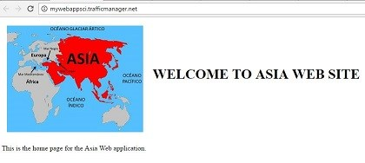Asia Web app

* Now let’s take testing one step further, by creating a VM in US region and testing traffic manager from the VM, as per configuration it should show the page of US web app.

If you want to know more about VMs in Azure please refer article [VM in Azure](http://www.sharecareinspire.com/virtual-machine-vm-in-azure/)

As expected following screen snap shows on left site my local machine which is in Asia region and on right side Azure VM which is in USA region.

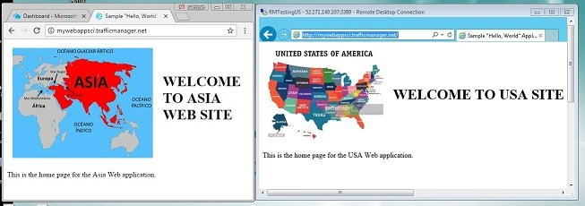USA Web app

I leave a exercise to you to test for Europe region.